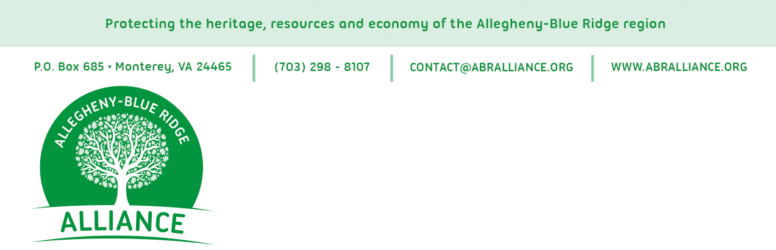

For release: September 8, 2014

Coalition Forms Over Proposed Dominion Pipeline
A coalition of 22 organizations from across Virginia and West Virginia has formed the Allegheny-Blue Ridge Alliance in response to the September 2 announcement of the proposed 550-mile natural gas pipeline from Harrison County, WV, to Robeson County, NC. Dubbed the “Atlantic Coast Pipeline” by its proponents, the project is a joint venture of Dominion Resources, Duke Energy, Piedmont Natural Gas and AGL Resources. The companies have not yet applied for a permit from the Federal Energy Regulatory Commission. Contrary to recent suggestions, construction of the project is not a certainty.
The Alliance and its member organizations are gravely concerned about the proposed route of the pipeline, which could disrupt some of the most ecologically sensitive areas in the Eastern United States, including more than 50 miles of public lands in the George Washington and Monongahela national forests. Further, much of the pipeline’s path, particularly in Highland and Augusta Counties in Virginia, would be built over fragile karst topography, a landscape formed from the dissolution of soluble rocks and characterized by underground drainage systems with sinkholes and caves. The impact on area water supplies of a pipeline built over such unstable geological formations could be significant. It could also present serious safety hazards to the pipeline.
Alliance members are also acutely concerned that the proposed project presents substantial unjustified risks and costs for the rural communities of the Allegheny-Blue Ridge region. These communities will bear the full impact of pipeline development, including the loss of private property, damage to their scenic landscape, and the risk of pollution, with few, if any, of the long-term economic benefits touted by proponents.
Founding members of the Allegheny-Blue Ridge Alliance are:
Allegheny Highlands Alliance
Augusta County Alliance
Conservation Partners
Cooper Conservation Advisors, LLC

Cowpasture River Preservation Association
Friends of Blackwater
Friends of Nelson County
Friends of Shenandoah Mountain
Friends of the Middle River
Greenbrier River Watershed Association
Highlanders for Responsible Development
Jackson River Preservation Association
Shenandoah Group of the Sierra Club
Shenandoah Valley Battlefields Foundation
Shenandoah Valley Network
Southern Environmental Law Center
Valley Conservation Council
Virginia Wilderness Committee
West Virginia Environmental Council
West Virginia Highlands Conservancy
West Virginia Rivers Coalition
Wild Virginia

More information about the Alliance and links to its member organization websites is at www.abralliance.org.

Contact:
Lewis Freeman, Steering Committee Chair
703-298-8107 or contact@abralliance.org

